報名表 APPLICATION FORM 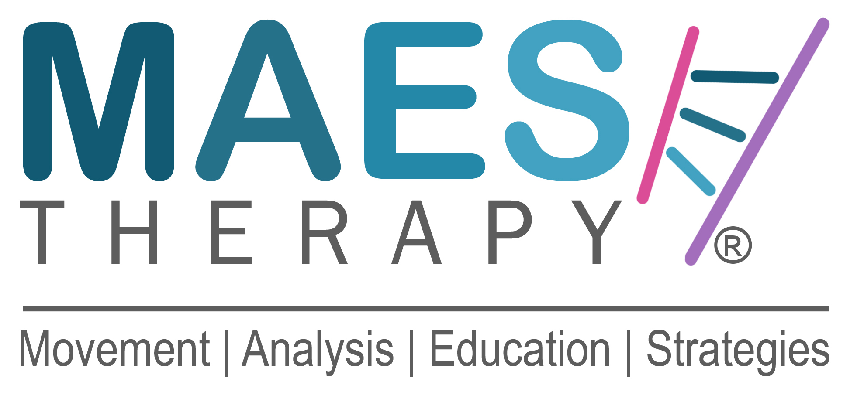

中文姓名 Original Name: 英文姓名First Name: Family Name:

職業別 Profession & Job Title (PT, OT, SLT, Doctor) :

住家地址 Full Home Address:

公司名稱 Name of Place of Work:

公司電子信箱 E-mail Work:

私人電子信箱 E-mail Private:

手機號碼Private Mobile No:

國際M.A.E.S.進階課程
針對腦性麻痺及類似神經發展疾患兒童之動作分析與教育策略
M.A.E.S. ‘A.R.T.’ Course
Advance - Refresh - Troubleshoot

五天的進階課程是是為已取得M.A.E.S.認證的兒童治療師所設計的繼續教育課程。
5-Day Advanced Course for Therapists who have already successfully completed the 4-Week M.A.E.S. Foundation Course.

本課程將協助M.A.E.S.認證治療師重溫及延伸M.A.E.S. Therapy的知識與治療技術。
An opportunity to go deeper, to refresh, question, troubleshoot and to advance your M.A.E.S. Therapy and treatment skills.

課程日期：2024年09月25日(三)至09月29日(日) ，共五天
Dates: Monday 20 September – Friday 24 September 2024 5-Days

課程時間：每日早上9點至下午5點
Timing: 09.00 - 17.00 Hrs. each day

課程地點：國立陽明交通大學 物理治療暨輔助科技學系
台北市北投區立農街二段155號 生醫工程館六樓 (詳細教室地點待公布)
Venue: (Exact room location awaits for confirmation)
Department of Physical Therapy and Assistive Technology
National Yang Ming Chiao Tung University
No. 155, Sec. 2, Linong St., Beitou Dist., Taipei City 112304, Taiwan

課程講師：Jean-Pierre Maes MCSP， M.A.E.S. Therapy International創辦人暨總監
Course Presented by: Jean-Pierre Maes MCSP, Founder & Director MAES Therapy

課程費用：
於2024年4月30日前繳費，物理治療學會會員45,500元台幣，非會員47,500元台幣
於2024年5月1日後報名，物理治療學會會員46,500元台幣，非會員48,500元台幣
Course Fee:
For TPTA member paid before 30 April 2024, the course fee is 45,500 TWD, for non-member 47,500 TWD
For TPTA member paid after 1 May 2024, the course fee is 46,500 TWD, for non-member 48,500 TWD
學員報名資格： 學員必須為已取得M.A.E.S.認證的兒童治療師
Course Participants’ Criteria:
Specialist 1-Week Advanced Course only open to Therapists who have already successfully completed the 4-Week M.A.E.S. Foundation Course.

請注意：學員須全程參與五天課程，不接受部分時段旁聽。
Attendance:
Course Participants to be aware that they must attend the 5 days in full.
Part attendance is not allowed.

保險聲明 Insurance statement:

“通過提交此報名表，我確認我是此文件上的本人，且是有治療師職業責任保險的本人”。
“By submitting this Application Form, I confirm that I am the person named on this form and I will be covered by my own Professional Liability Insurance if I attend this course”.

姓名Full Name ( Print your name ) :-

_________________________________________________________________________
報名程序
Application:

- 請完成此報名表，連同履歷email至
課程承辦人：蕭茗榕物理治療師 siaomingrong@gmail.com

To apply for a place on the course, please complete this Application Form
And e-mail to:

TPTA Contact for this course: Ming-Rong Siao, Physiotherapist
E: siaomingrong@gmail.com

- 付款
在講師審核報名表及履歷後，承辦人將email提供繳費方式
How to Pay:
Once this Application Form and accompanying CV have been submitted and accepted, details about how to make the payments will be provided.

- 報名確認
在主辦單位確認學費付清後，學員將收到承辦人email確認報名成功
Confirmation:
Upon receipt of the full Course Fee, you will receive an email confirming your Registration and place on the course ( subject to receipt of full payment by the deadline date).

M.A.E.S. Movement Analysis Education Strategies Therapy

